
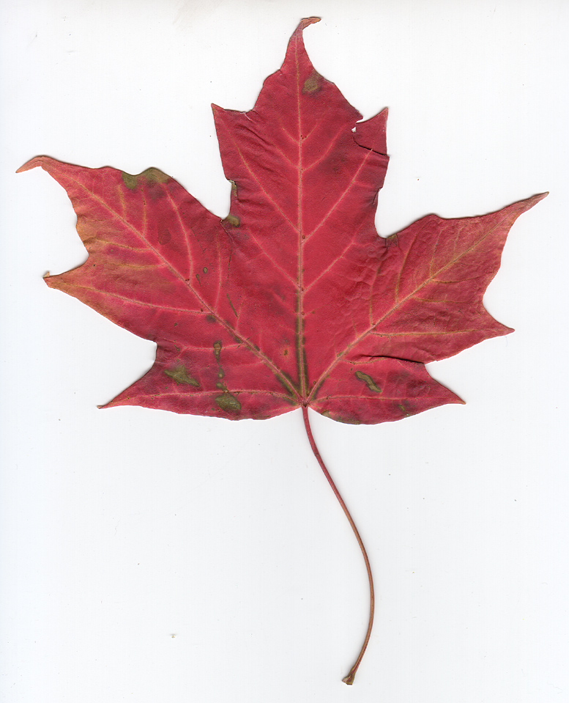
O Ursalia!
Teach - With - Music !

Songs and Stories From the Northland

From Contact to Confederation

Welcome!

Isn’t learning history so much more interesting if it comes along with a catchy beat? Our Canadian history is full of amazing people and stories; a point that is sometimes lost on our students as they listen to us discuss our history. However, something changes when they hear a song about it. Students are engaged by music, and they will retain information presented in song long after the images and words of the textbooks have dissolved from their memories.

Teach with music – watch them come alive!

How To Use This Resource

WARNING!!! – The ultimate goal of this project is to foster the development of critical analysis skills. For example, you could: discuss the motivation for the writing of the song, the narrator’s perspective, and compare the song to other documents. Do not feel as though you must use the worksheets! Yes, we have created beautiful worksheets for your use, however please don’t kill the student’s enjoyment of the music with the worksheets. Use them as a guide for your teaching – not as a lesson plan. Each song has some of the following parts:

Vocabulary – to help make sure the students understand the song. Students can complete this individually of you may want to just discuss and define the words as a class.
Do You Know It? – this section deals with background knowledge the students may or may not have. It should be done with the teacher, or resources should be made available to assist the students with this part.
Did You Catch It? – the questions in this section are straight forward, and most students should be able to answer them after hearing the song once.
Do You Get It? – this section deals with higher level thinking questions, and may require the students to think critically about the material and its purpose.
Extensions and Activities! – if you’re interested in expanding on the ideas presented in this song, we have provided you with a few extensions.
Teacher’s Guide – here you will find some handy background knowledge both on the song and the artist, as well as an answer key and ideas for other resources.

1
This resource package was created by teachers in Southern Alberta to help other teacher incorporate more music into their classrooms. Our thanks goes out to SAPDC (Southern Alberta Professional Development Consortium), who provided funds to get this project going and for project meetings. This project also represents countless volunteer hours put in by the following committee. They put a lot of heart into this project, so if you see one of them, give them a hug and say, “Thanks!” The committee was made up of:

About This Resource

David Fletcher LCI
Robbie Van Orman LCI
Dawn King-Hunter GS Lakie
Lorraine Wolsey GS Lakie
Robin Haney Gilbert Paterson
Bev Fisher Gilbert Paterson
Kae McFadzen Gilbert Paterson
Jamie Michaud DA Ferguson

Table of Contents

Page Description

Pages 1 - 2 Front Matter
Pages 3 - 18 Song Lyrics
Pages 19 - 21 #1 Thanadelthur – Mike Ford
Pages 22 - 24 #2 Northwest Passage – Stan Rogers
Pages 25 - 27 #3 Les Voyageurs – Mike Ford
Pages 28 - 31 Voyageurs supplement
Pages 32 - 34 #4 Northwest Company – John Spearn
Pages 35 - 37 #5 Acadian Driftwood – The Band
Page 38 #6 United Empire Loyalists – The Evaporators
Pages 39 - 42 #7 Secord’s Warning – Tanglefoot
Pages 43 - 45 #8 War of 1812 – Three Dead Trolls in a Baggie
Pages 46 – 48 #9 Battle of New Orleans – Johnny Horton
Pages 49 – 51 #10 La Patriote – Mike Ford
Pages 52 – 54 #11 Turn Them Ooot – Mike Ford
Pages 55 – 57 #12 Sir John A. – Mike Ford
Pages 58 – 60 #13 Ribbon of Broken Dreams – John Spearn
Pages 61 – 63 #14 Canadian Railroad Trilogy – Gordon Lightfoot
Pages 64 – 66 #15 Louis and Gabriel – Mike Ford
Pages 67 – 69 #16 Canada Needs You – Mike Ford

2

